ND CONSTRUCTION
& ENGINEERING
(S) PTE. LTD.
  - Company Profile
Electrical installation and load upgrading services
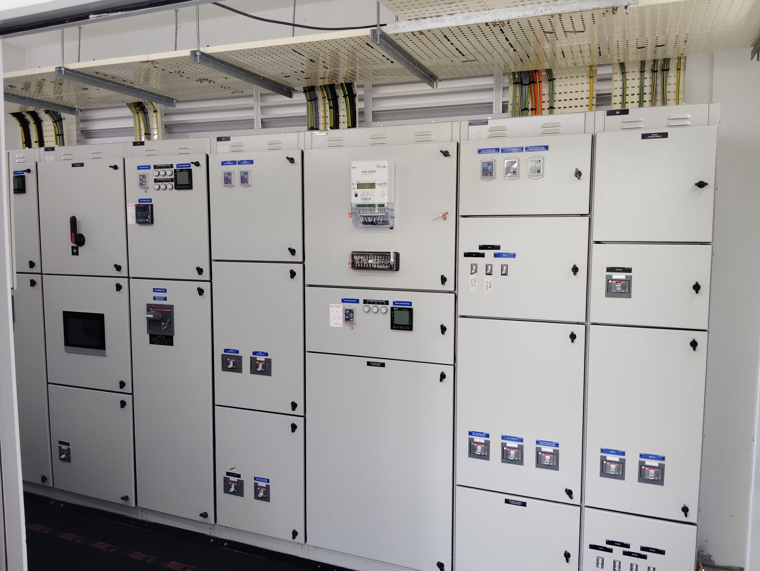
Electrical distribution equipment shown in the supplied site photographs
UEN 202316291K | Singapore
RCU panel installation • Isolator relocation • Electrical power upgrades
DB and RCU termination • Unistrut works

About the Company
ND CONSTRUCTION & ENGINEERING (S) PTE. LTD. provides electrical installation, modification and power system upgrading services in Singapore. Our work supports the installation and adaptation of electrical equipment within existing buildings and project sites, with a particular focus on Electrical Load Upgrading Programme works.
Our scope includes mounting RCU panels on walls, relocating isolators from existing Unistrut supports to ceiling surfaces, upgrading electrical power systems, and carrying out DB and RCU terminations. Associated Unistrut works support the required installation arrangements.
The project records supplied for this profile cover assignments from August 2023 onward and include work with several main contractors across residential and neighbourhood locations in Singapore. We work within the agreed subcontract scope and coordinate installation activities with the main contractor and site team.

Company Particulars
Particulars | Details
Registered name | ND CONSTRUCTION & ENGINEERING (S) PTE. LTD.
Unique Entity Number | 202316291K
Classification | ME05 (L1), as stated in the company information supplied
Office address | 629 Aljunied Road, #07-19, Cititech Industrial Building, Singapore 389838
Telephone | +65 9355 5975  +65 9644 5886
Email | shakenur3@gmail.com  ND_management@outlook.com

Our Direction
Our aim is to build lasting working relationships through careful execution, clear coordination and dependable electrical installation work. We focus on understanding the agreed scope and delivering installations that support operation, inspection and future maintenance.

Electrical Installation Services

RCU Panel Installation
We undertake wall mounting of RCU panels at designated locations. The work involves positioning and securing the panel, coordinating cable entry arrangements and allowing appropriate access for operation and maintenance, in line with approved project details.

Isolator Relocation
We relocate isolators from existing Unistrut-mounted positions to ceiling surfaces to suit revised installation arrangements. The scope includes coordinated disconnection, suitable mounting, cable route adjustments where specified, and reconnection under the agreed work procedures.

Electrical Power System Upgrading
We carry out installation and modification works associated with electrical power system upgrades. The extent of each upgrade is defined by the project requirements and approved technical details, including relevant distribution connections and associated support works.
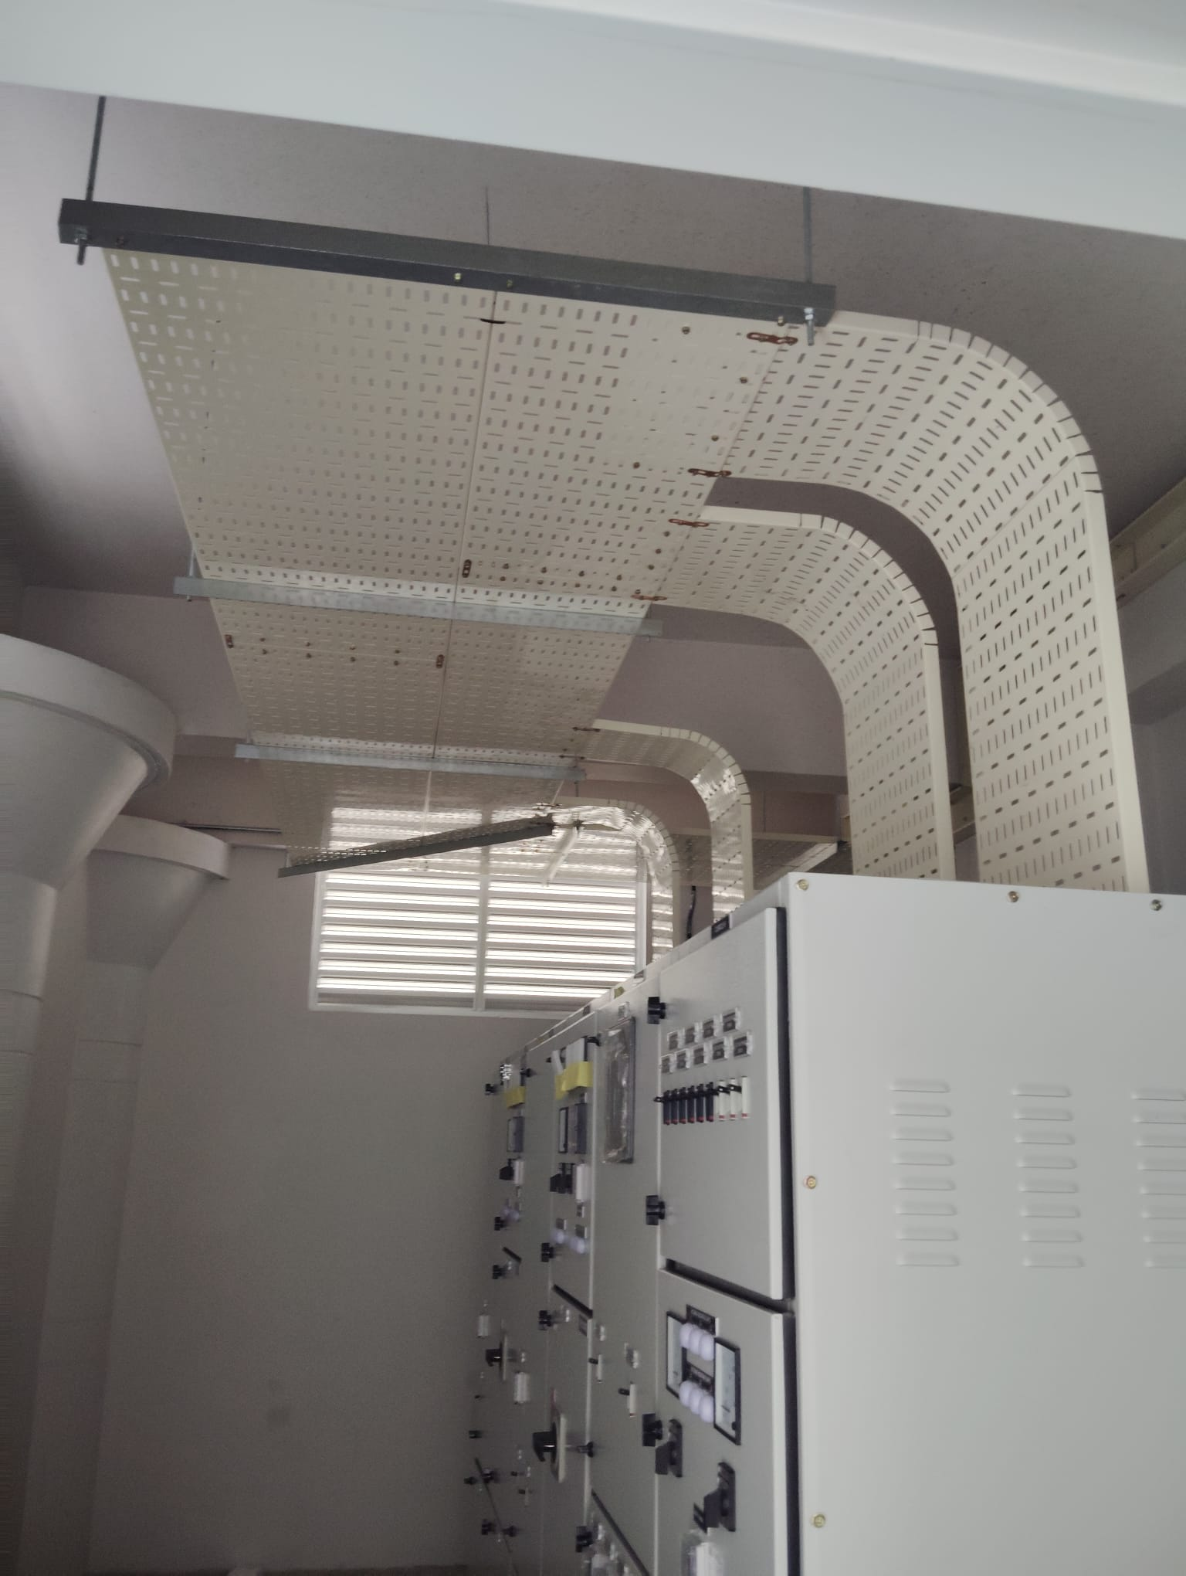
Cable containment and electrical equipment installation

Supports and Site Installation

Unistrut Works
We undertake Unistrut works associated with the electrical installation scope. Support arrangements, fixing methods and finishing requirements are established from the approved project details. The precise activity described as “termination of Unistrut” in the source scope should be confirmed in each quotation or work order.

Coordination at Site
Work sequencing is coordinated with the main contractor and other trades. Mounting locations, access requirements, existing services and any required shutdown arrangements are considered before installation begins. Changes to the agreed scope are clarified with the responsible project team.
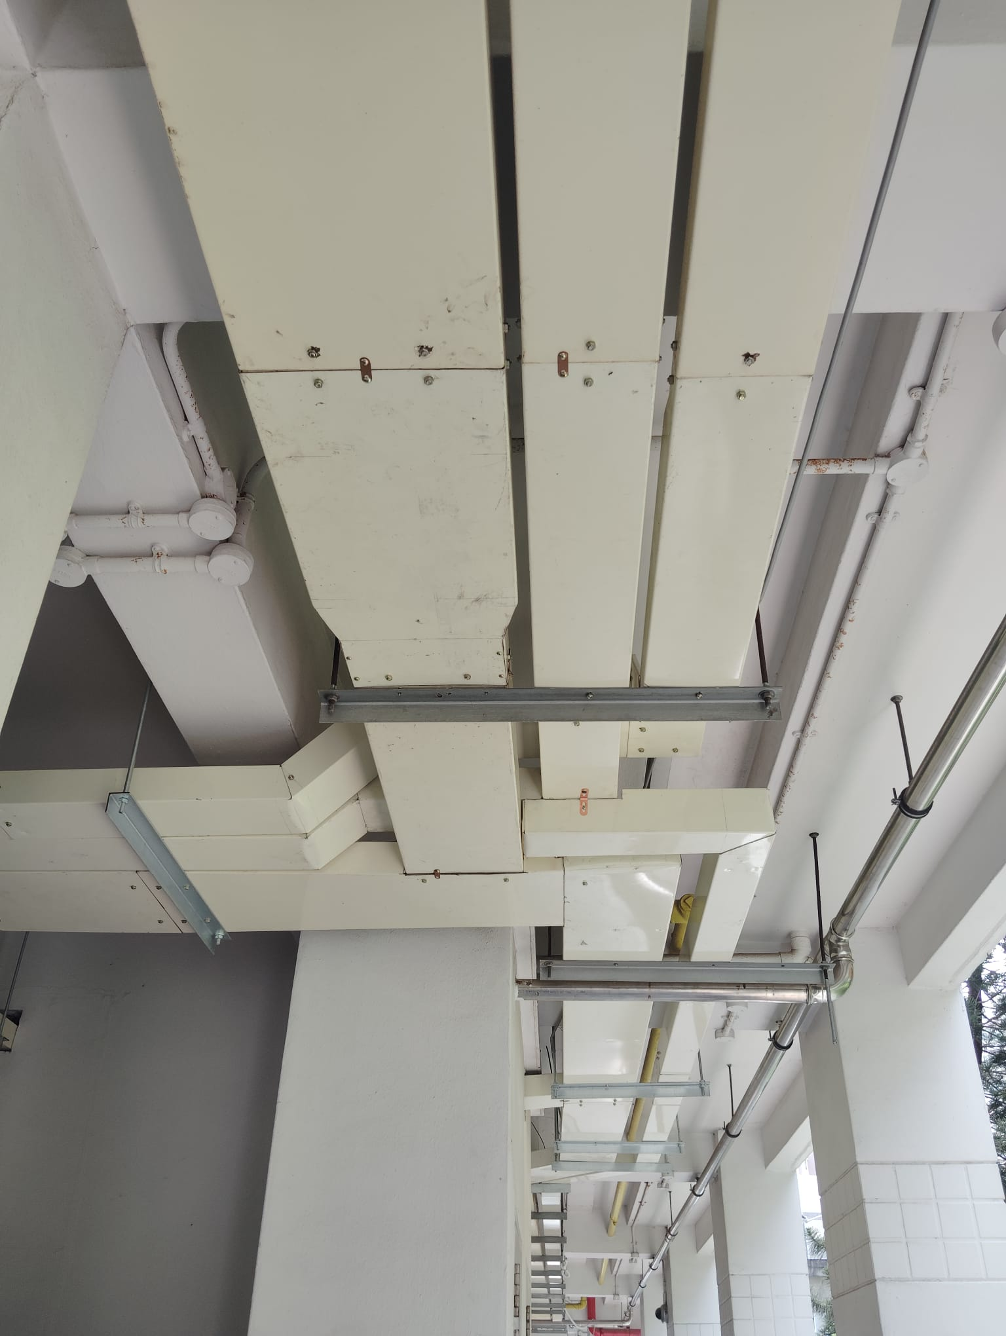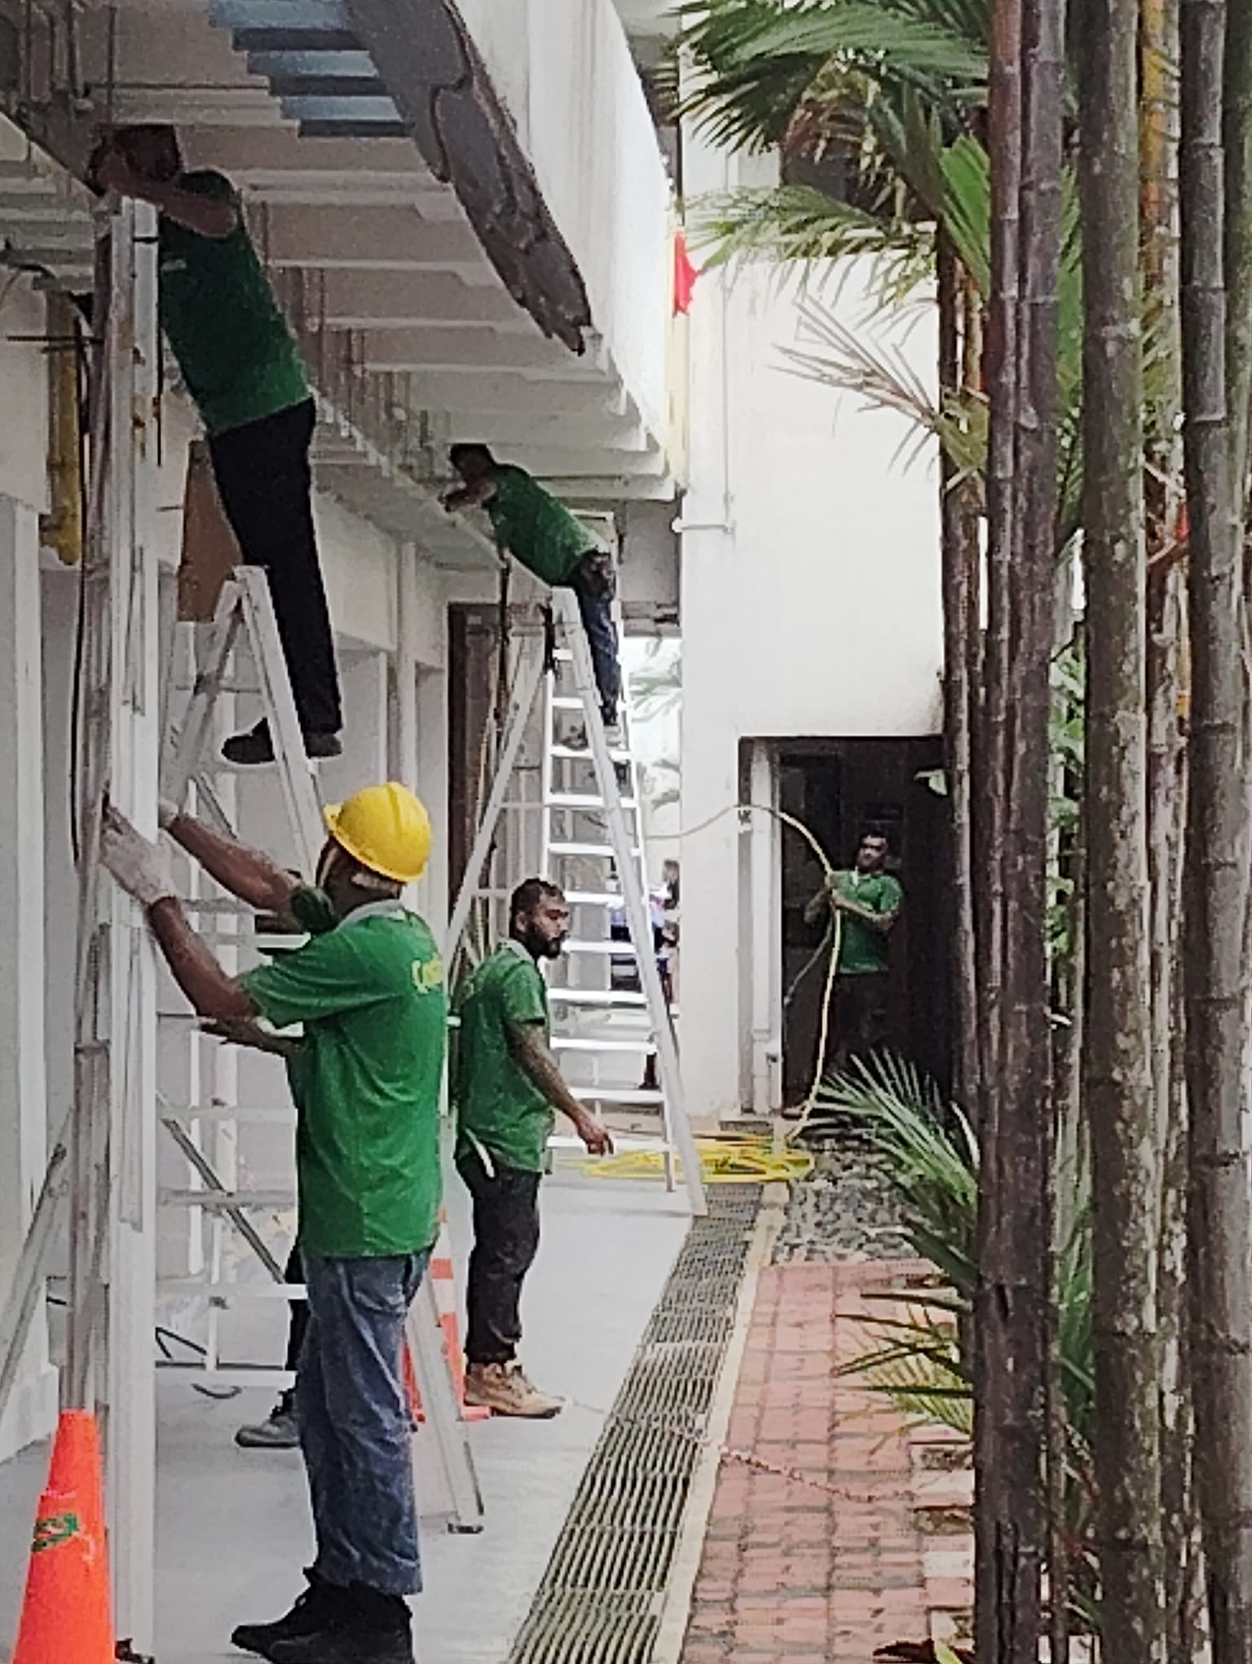
Site photographs showing overhead support arrangements and installation activity.

Electrical Termination Works

Distribution Board Termination
We undertake cable termination at distribution boards according to the approved circuit arrangements. The work includes conductor preparation, connection to designated terminals and organisation of the connected cables within the agreed scope. Appropriate termination accessories and identification are selected to suit the installation requirements.

RCU Termination
We carry out RCU termination in accordance with the applicable wiring information and terminal arrangements. Cable identification, connection accuracy and internal wiring organisation are considered during execution. The RCU function and full equipment designation are confirmed for each project.
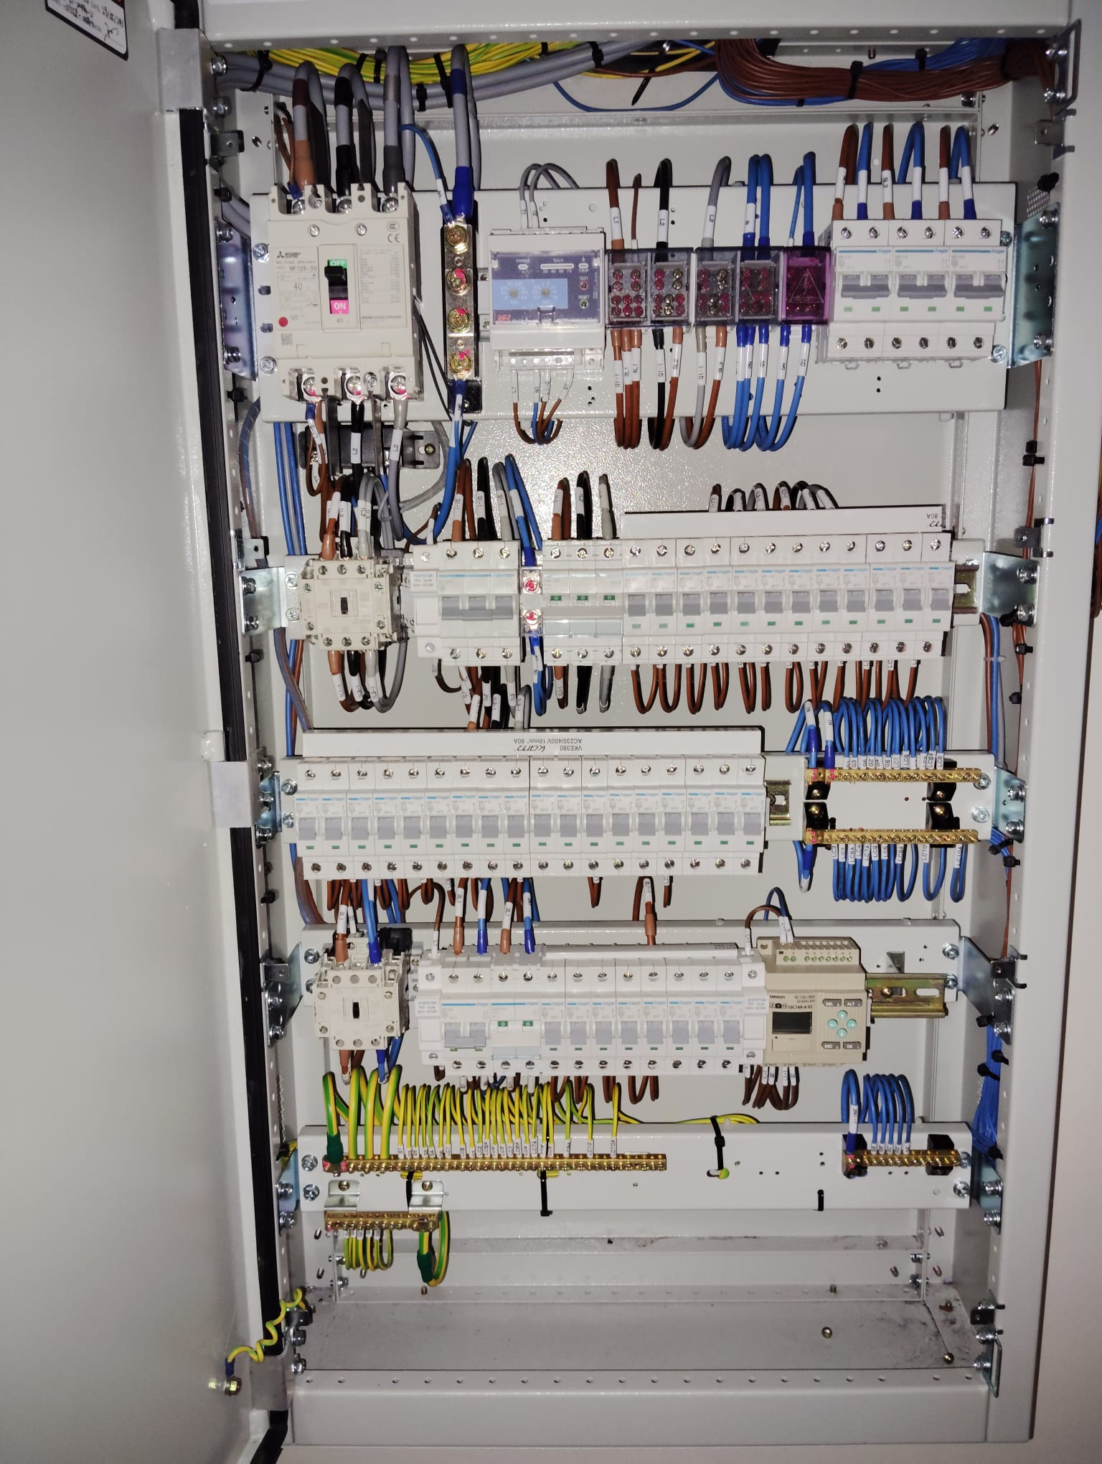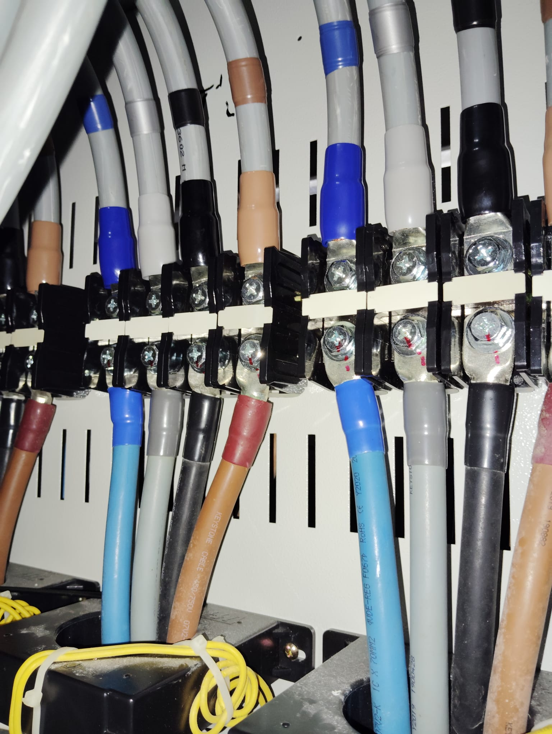
Supplied photographs showing panel wiring and cable termination details.

Project Portfolio
The following assignments are recorded in the company’s supplied project schedule. Dates describe the recorded work periods; they do not independently certify completion or current status.
Main contractor | Project and location | Recorded period | Blocks
UTTAMA ENGINEERING PTE. LTD. | UEPL-ND-14-23-001 | Aug 2023–Oct 2025 | Condo 500–521
KHOON ENGINEERING CONTRACTOR PTE. LTD. (under LA Eng.) | ELUP Batch 2 Project 1  Pasir Ris and Tampines | Apr 2024–Aug 2025 | 63, 64, 65 and 66
KHOON ENGINEERING CONTRACTOR PTE. LTD. (under LA Eng.) | ELUP Toa Payoh | Jul 2024–Sep 2025 | 100–100C  12 blocks stated
SHIN KHAI CONSTRUCTION PTE. LTD. (under LA Eng.) | ELUP Batch 2 Project 4  Pasir Ris and Tampines | Jun 2025–Jan 2026 | 393, 394, 395 and 396
SHIN KHAI CONSTRUCTION PTE. LTD. (under LA Eng.) | ELUP Batch 2 Project 4  Additional block entry | Jun 2025–Jan 2026 | 500–521  23 blocks stated
COSBY PTE. LTD. (under LA Eng.) | ELUP Batch 3 Project 4  Central Zone | May 2025–Sep 2026 | Blocks 4–6
COSBY PTE. LTD. (under LA Eng.) | ELUP Batch 3 Project 4  Gim Moh Road | May 2025–Sep 2026 | Blocks 4–6
COSBY PTE. LTD. (under LA Eng.) | ELUP Batch 3 Project 4  Hougang | Jan 2026–ongoing* | 422–427  6 blocks stated
KSK ENGINEERING PTE. LTD. | ELUP Batch 3 Project 3  Pasir Ris Street 52 | Dec 2025–ongoing* | 531–569  17 blocks stated
* Ongoing status is reproduced from the supplied schedule. Block counts are retained as stated and may refer to selected blocks within a range. The Central Zone and Gim Moh Road entries share merged period and block fields in the source workbook.

Our Approach and Contact

Quality and Workmanship
Our approach is to follow the agreed installation details, use materials suited to the application, and pay attention to mounting security, connection workmanship and identification. Completed work is reviewed against the agreed scope, with outstanding items addressed through the project team.

Safety and Responsible Execution
Electrical works require controlled access and appropriate isolation arrangements. Project execution should follow the site’s safety procedures, permit requirements and applicable technical requirements. Tasks requiring specific authorisation, supervision or testing are coordinated with appropriately qualified personnel.

Communication and Handover
We aim to keep the main contractor informed of progress, access constraints and installation issues. Inspection, testing and handover records are coordinated as required by the contract, with any changes reflected in the agreed completion information.
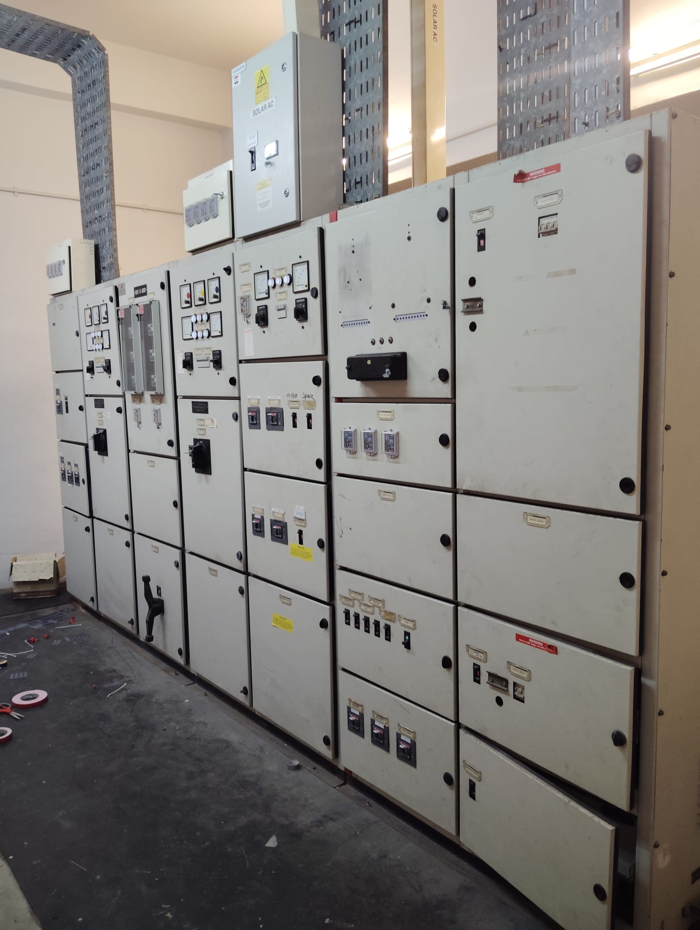
Electrical distribution installation shown in the company’s supplied photographs

Contact Our Team
ND CONSTRUCTION & ENGINEERING (S) PTE. LTD.
629 Aljunied Road, #07-19, Cititech Industrial Building
Singapore 389838
Telephone: +65 9355 5975 / +65 9644 5886
Email: shakenur3@gmail.com / ND_management@outlook.com

